Chapter 7, Solution 40.

- Before t = 0, 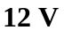.
After t = 0, 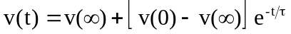
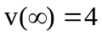, 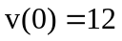, 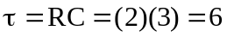
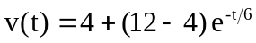
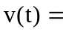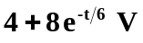

- Before t = 0, .
After t = 0, 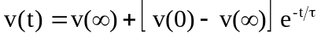
After transforming the current source, the circuit is shown below.

+
−
2 
4 
12 V
t = 0
5 F

,  